How can we increase revenue

from

Catch the Pink Flamingo?

Gopavarapu Divya

# Context

* Catch The Pink Flamingo
  + a mobile game ➢ Eglence Inc.
  + a multi-user game
* Objective: to catch as many Pink Flamingos as possible by following the missions provided by real-time prompts in the game and cover the map provided for each level.

# Problem Statement



flamingo-data combined-data chat-data

# Data Exploration Overview

* 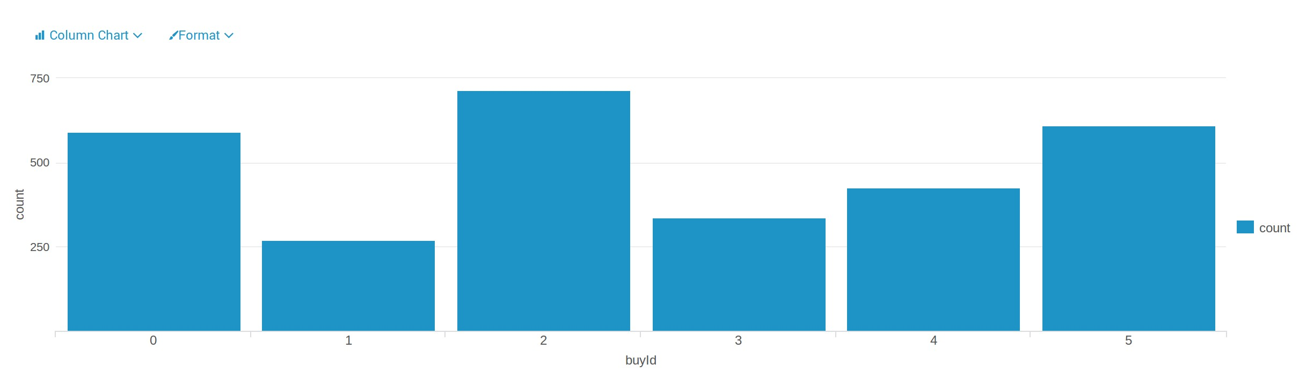the item “2” is the most purchased, the item “1” is the least purchased
* the item “5” made the most money, and the item “1” made the least

money

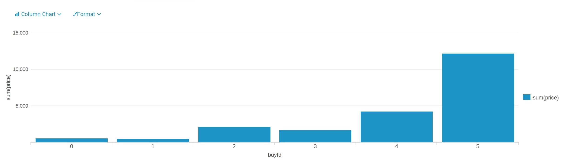

# Classification

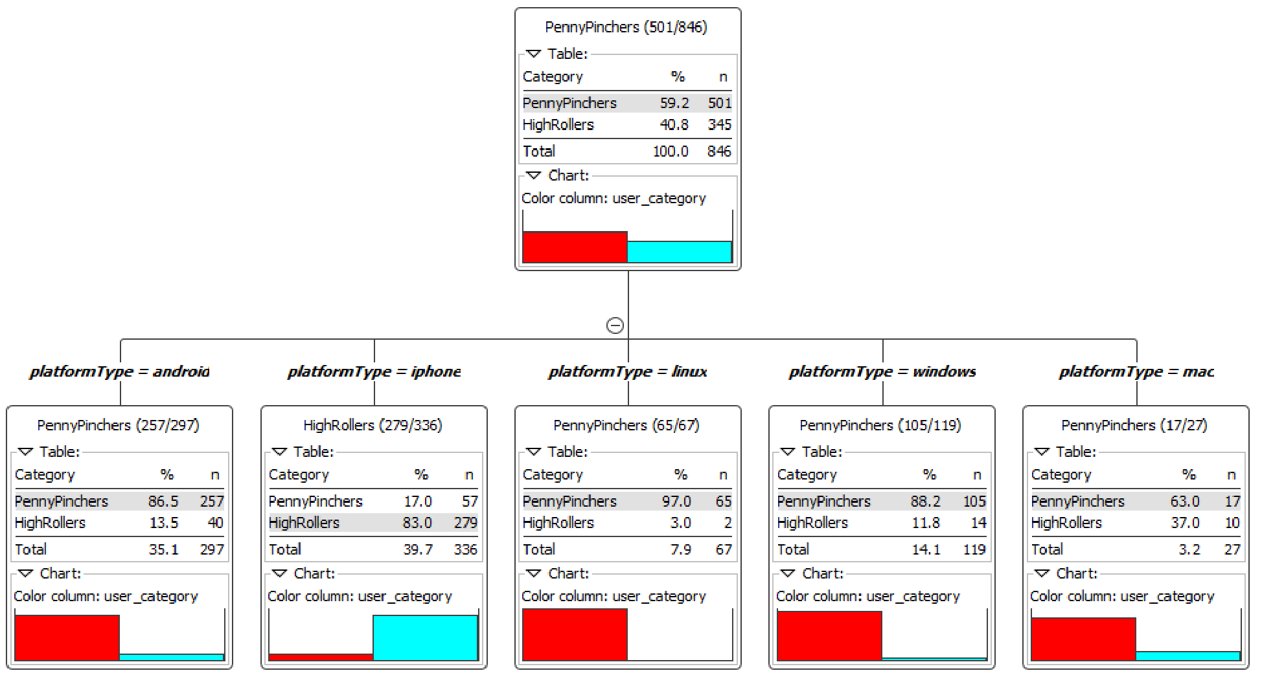

•

HighRollers

:

] 5, ∞

[

PennyPinchers

:

]

-

∞, 5]

•

most

users which on the

platform

**iPhone**

are

HighRollers

# Clustering

|  |  |  |  |
| --- | --- | --- | --- |
| Cluster | Total ad clicking | Total game clicking | Revenue |
| 1 | 25.12 | 362.50 | 35.36 |
| 2 | 32.05 | 2393.95 | 41.20 |
| 3 | 36.47 | 953.82 | 46.16 |

* low level spending user (L) → neutral user (N)
* high level spending user (H)
* ad clicking amount of H is 1.45 times more than L and 1.14 times more than N
* game clicking amount of H is 2.63 times more than L
* revenue from H is 1.31 times higher than L and 1.12 times higher than N

# Chat Graph Analysis

|  |  |  |  |  |  |  |  |  |  |  |  |  |  |  |  |  |  |  |  |  |  |  |  |  |  |  |  |  |  |  |  |  |  |  |  |  |  |  |  |  |  |  |  |  |  |  |  |  |  |  |  |  |  |  |  |  |  |  |  |  |  |  |  |  |  |  |  |  |  |  |  |  |  |  |  |  |  |  |  |  |  |
| --- | --- | --- | --- | --- | --- | --- | --- | --- | --- | --- | --- | --- | --- | --- | --- | --- | --- | --- | --- | --- | --- | --- | --- | --- | --- | --- | --- | --- | --- | --- | --- | --- | --- | --- | --- | --- | --- | --- | --- | --- | --- | --- | --- | --- | --- | --- | --- | --- | --- | --- | --- | --- | --- | --- | --- | --- | --- | --- | --- | --- | --- | --- | --- | --- | --- | --- | --- | --- | --- | --- | --- | --- | --- | --- | --- | --- | --- | --- | --- | --- | --- |
| |  |  | | --- | --- | | Users | Number of Chats | | 394 | 115 | | 2067 | 111 | | 209 | 109 | | 1087 | 109 | | 554 | 107 | | 516 | 105 | | 1627 | 105 | | 999 | 105 | | 668 | 104 | | 461 | 104 | |  | |  |  | | --- | --- | | Teams | Number of Chats | | 82 | 1324 | | 185 | 1306 | | 112 | 957 | | 18 | 844 | | 194 | 836 | | 129 | 814 | | 52 | 788 | | 136 | 783 | | 146 | 746 | | 81 | 736 | |  | |  |  |  | | --- | --- | --- | | Users | Teams | Number of Chats | | 394 | 63 | 115 | | 2067 | 7 | 111 | | 209 | 7 | 109 | | 1087 | 77 | 109 | | 554 | 181 | 107 | | 1627 | 7 | 105 | | 516 | 7 | 105 | | 999 | 52 | 105 | | 461 | 104 | 104 | | 668 | 89 | 104 | |

Chattiest Users Chattiest Teams

# Recommendation

* Offer more products to iPhone users
* Provide more products to “high level spending user”
* Provide some fixed pay packages or promotion to users, especially to “low level spending user”